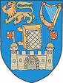
The University of Dublin
Trinity College Dublin
Note to Applicant:
It is the responsibility of individual applicants to upload their academic records as part of the application process to The University of Dublin, Trinity College Dublin.
The University of Dublin, Trinity College Dublin may request verification of these documents at any time from the issuing Institution. This may involve a charge from the issuing Institution.
Applicants must complete and sign this authorisation form and upload to their application as part of the University of Dublin, Trinity College Dublin application process.

Please complete and upload one form for each of the Institutions from which you have received an academic award (certificate/Diploma/Degree/Higher Degree).
TCD Ref #:
Last/Family Name: Thakar |  | First/Given Name: Deep
Previous Name (if applicable): | Date or Birth (dd/mm/yyyy):  13/01/2000 |  |  | Email: deep.thakar.13@gmail.com
Institution Name:  Thakur College of Science and Commerce | Dates Attended:  From ___2017________ to ___2020__________  mm/yy mm/yy
Course Name (if applicable):  Bachelor’s in Science (Computer Science) |  |  | Year of Award (if applicable): 2020
Student ID Number (at sending Institution):

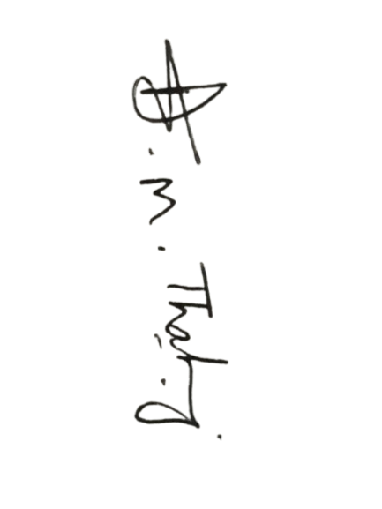
I hereby authorise the release of my academic records to The University of Dublin, Trinity College Dublin.

Applicant’s Signature: Date: 04/01/2020

